API Tokens – Bachicute : TDrJCvHK0RMKKeghx4mJ62F1

Issues-> Search for Issues->

Create a JQL

Project = “xx” 🡪 Search -> Save the filter

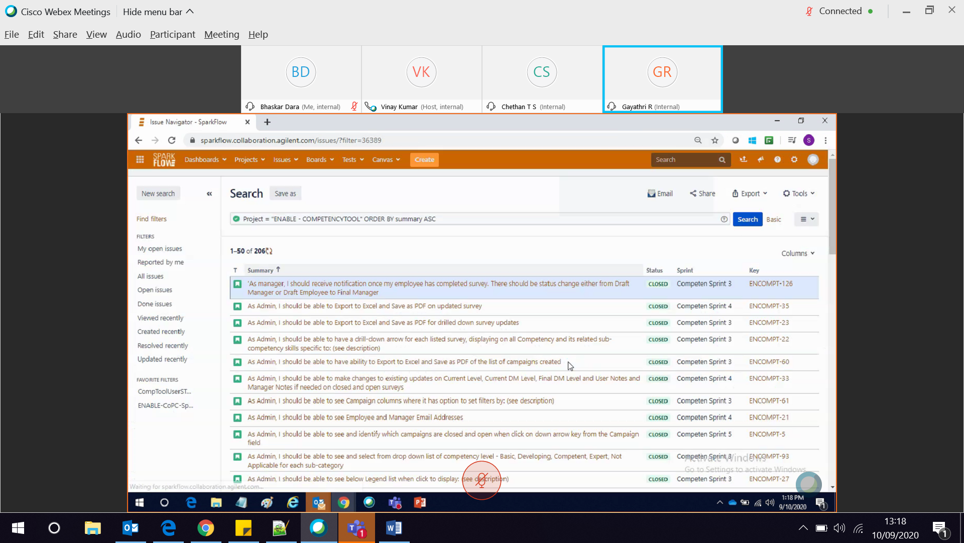

https://sparkflow.collaboration.agilent.com/issues/?filter=36389

Take the URL of the filter from screenshot

Excel -> data -> new query ->

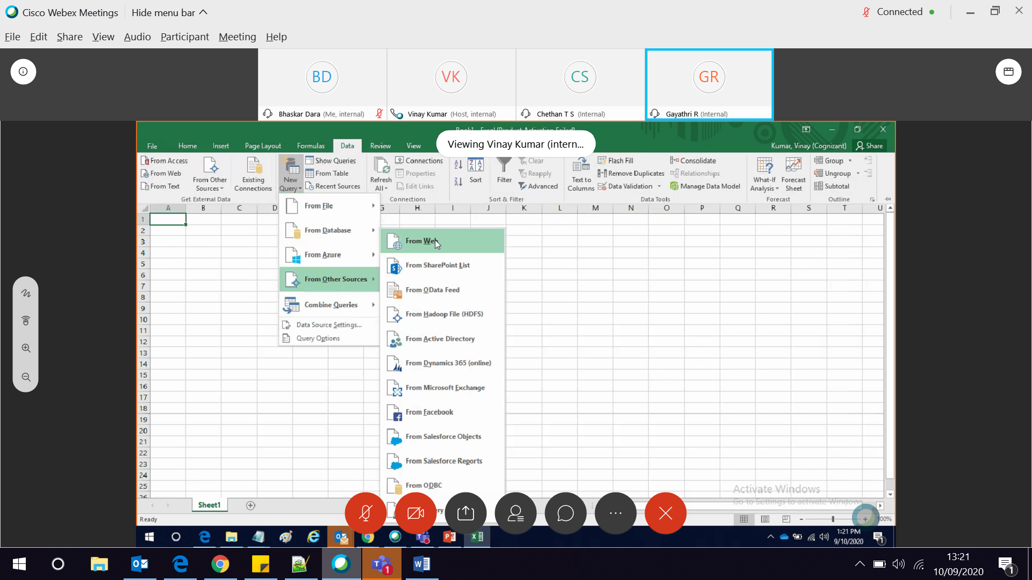

Modified URL for excel

<https://sparkflow.collaboration.agilent.com/sr/jira.issueviews:searchrequest-csv-current-fields/36389/SearchRequest-36389.csv>

<https://bdara.atlassian.net/issues/?filter=10002>

<https://bhaskardara.atlassian.net/issues/?filter=10006>

[https://bhaskardara.atlassian.net/sr/jira.issueviews:searchrequest-csv-current-fields/10009/SearchRequest-10009.csv](https://bhaskardara.atlassian.net/sr/jira.issueviews:searchrequest-csv-current-fields/10008/SearchRequest-10008.csv)

Albertsons:

https://jira.safeway.com/issues/?filter=25664

<https://jira.safeway.com/sr/jira.issueviews:searchrequest-csv-current-fields/25664/SearchRequest-25664.csv>

TDrJCvHK0RMKKeghx4mJ62F1

https://abbvie-completepro.atlassian.net/issues/?filter=10042

[https:// abbvie-completepro.atlassian.net /sr/jira.issueviews:searchrequest-csv-current-fields/10002/SearchRequest-10002.csv](https://bdara.atlassian.net/sr/jira.issueviews:searchrequest-csv-current-fields/10002/SearchRequest-10002.csv)

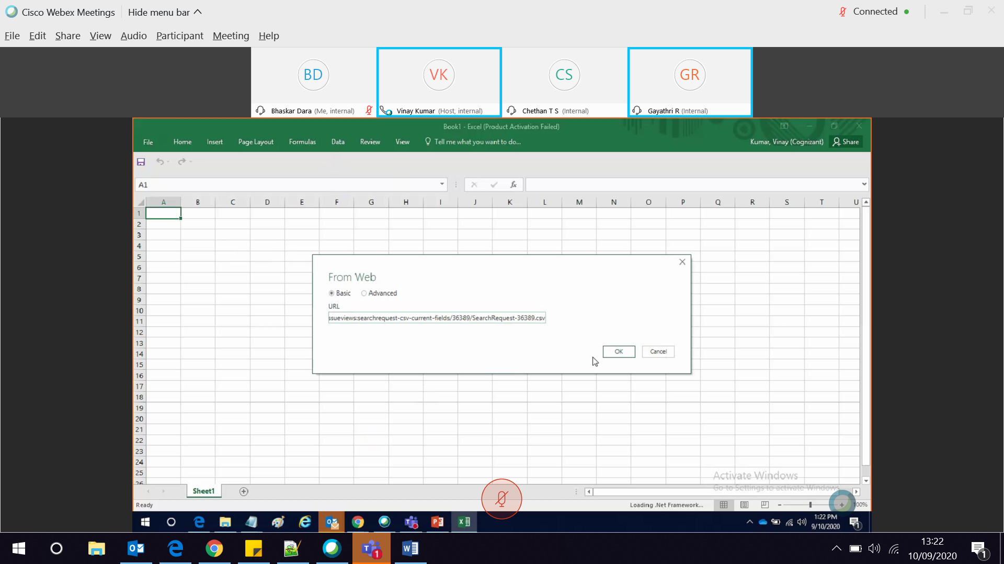

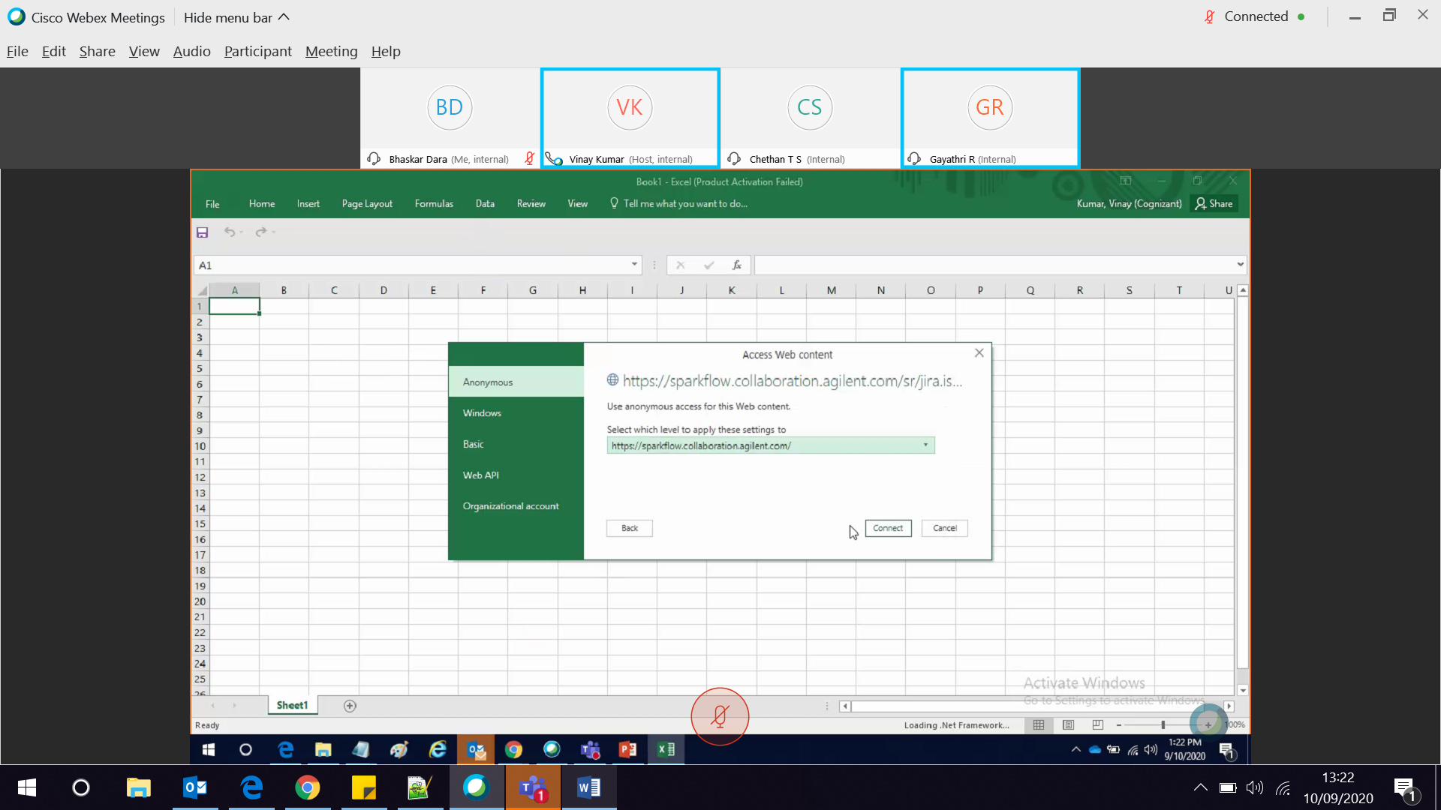

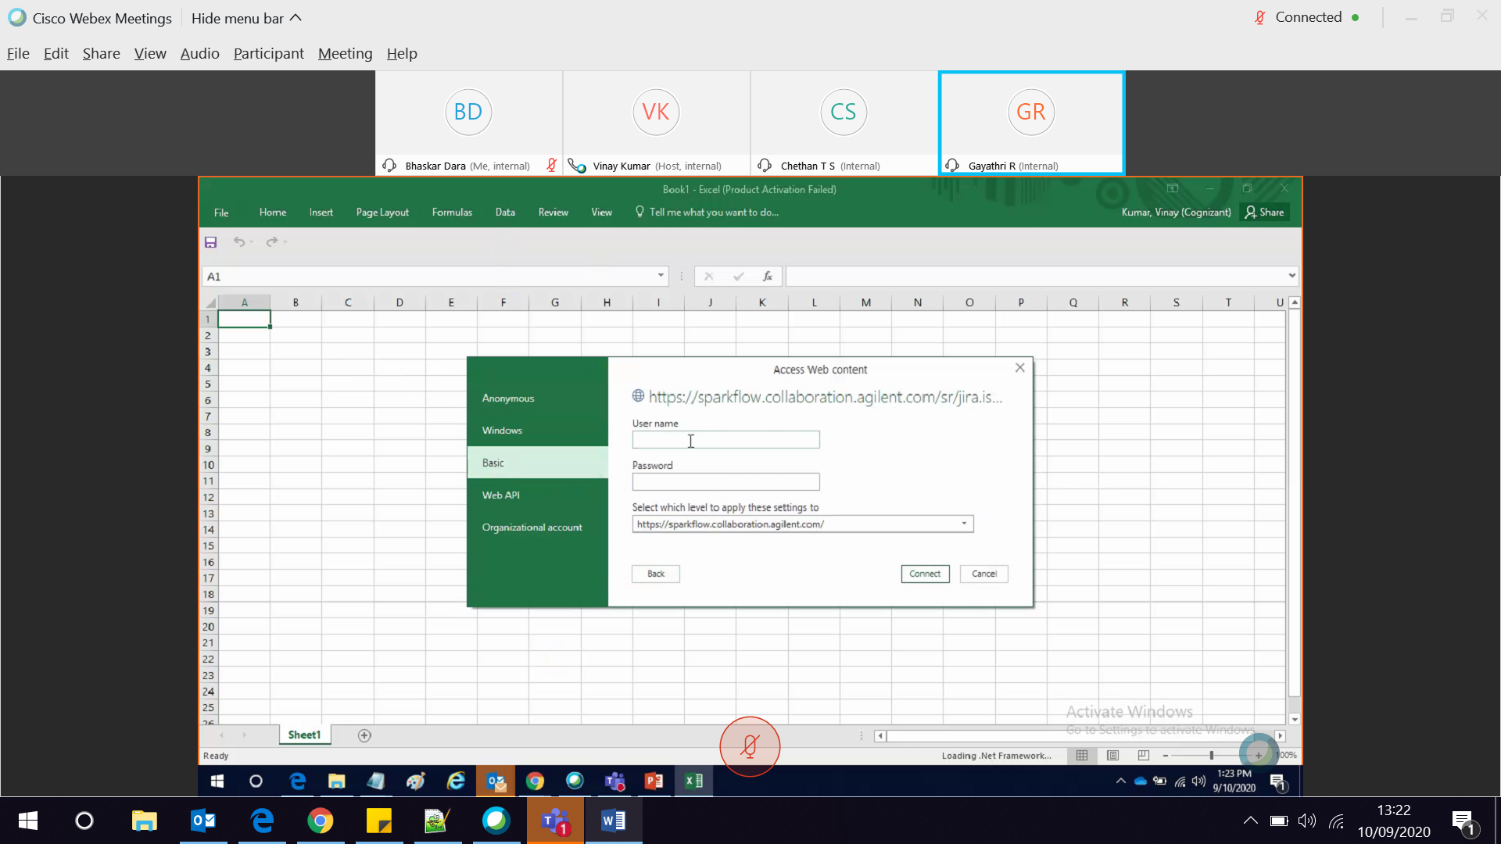

Give username and token generated from JIRA as password.

Link to generate token : <https://id.atlassian.com/manage/api-tokens>

Sign in to jira

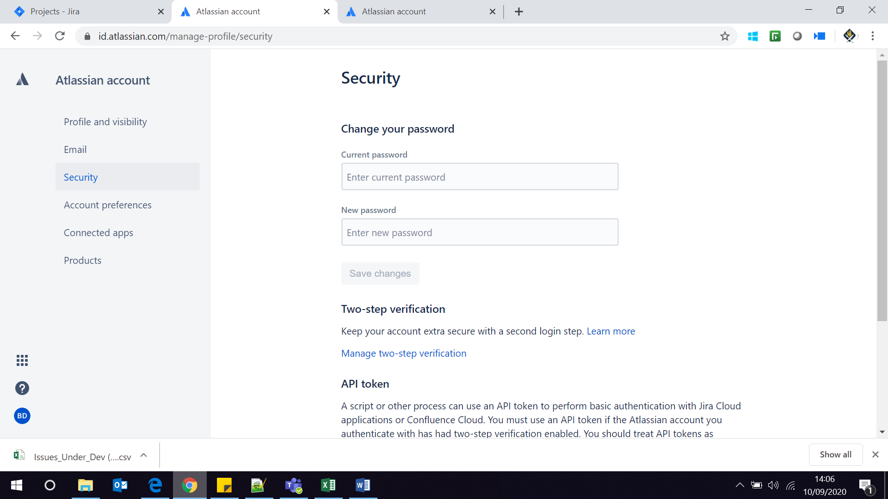

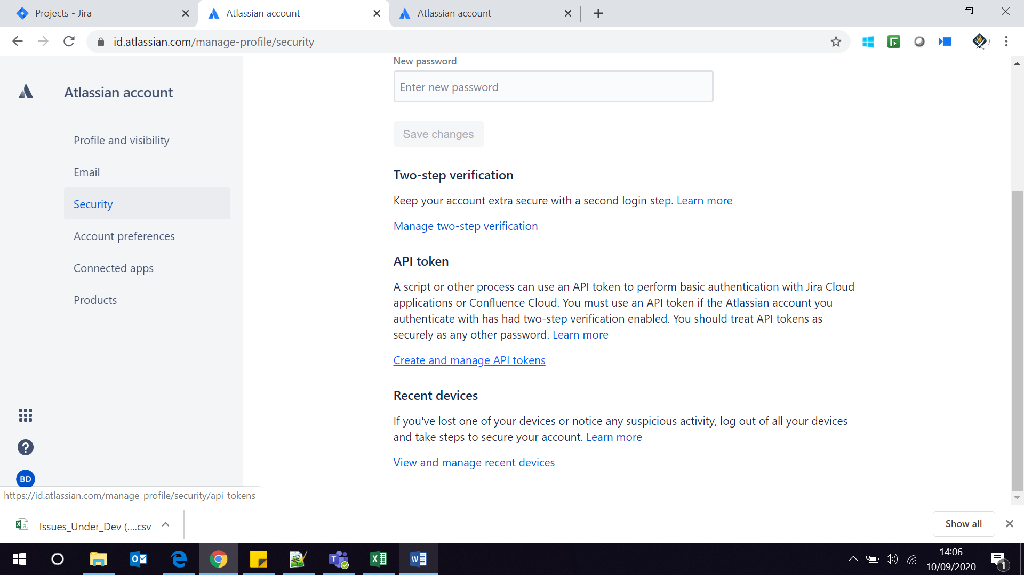

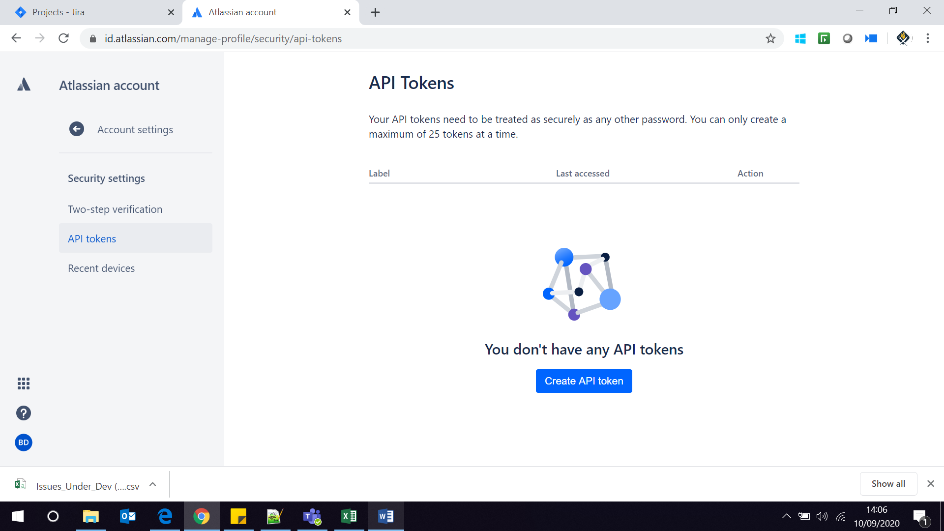

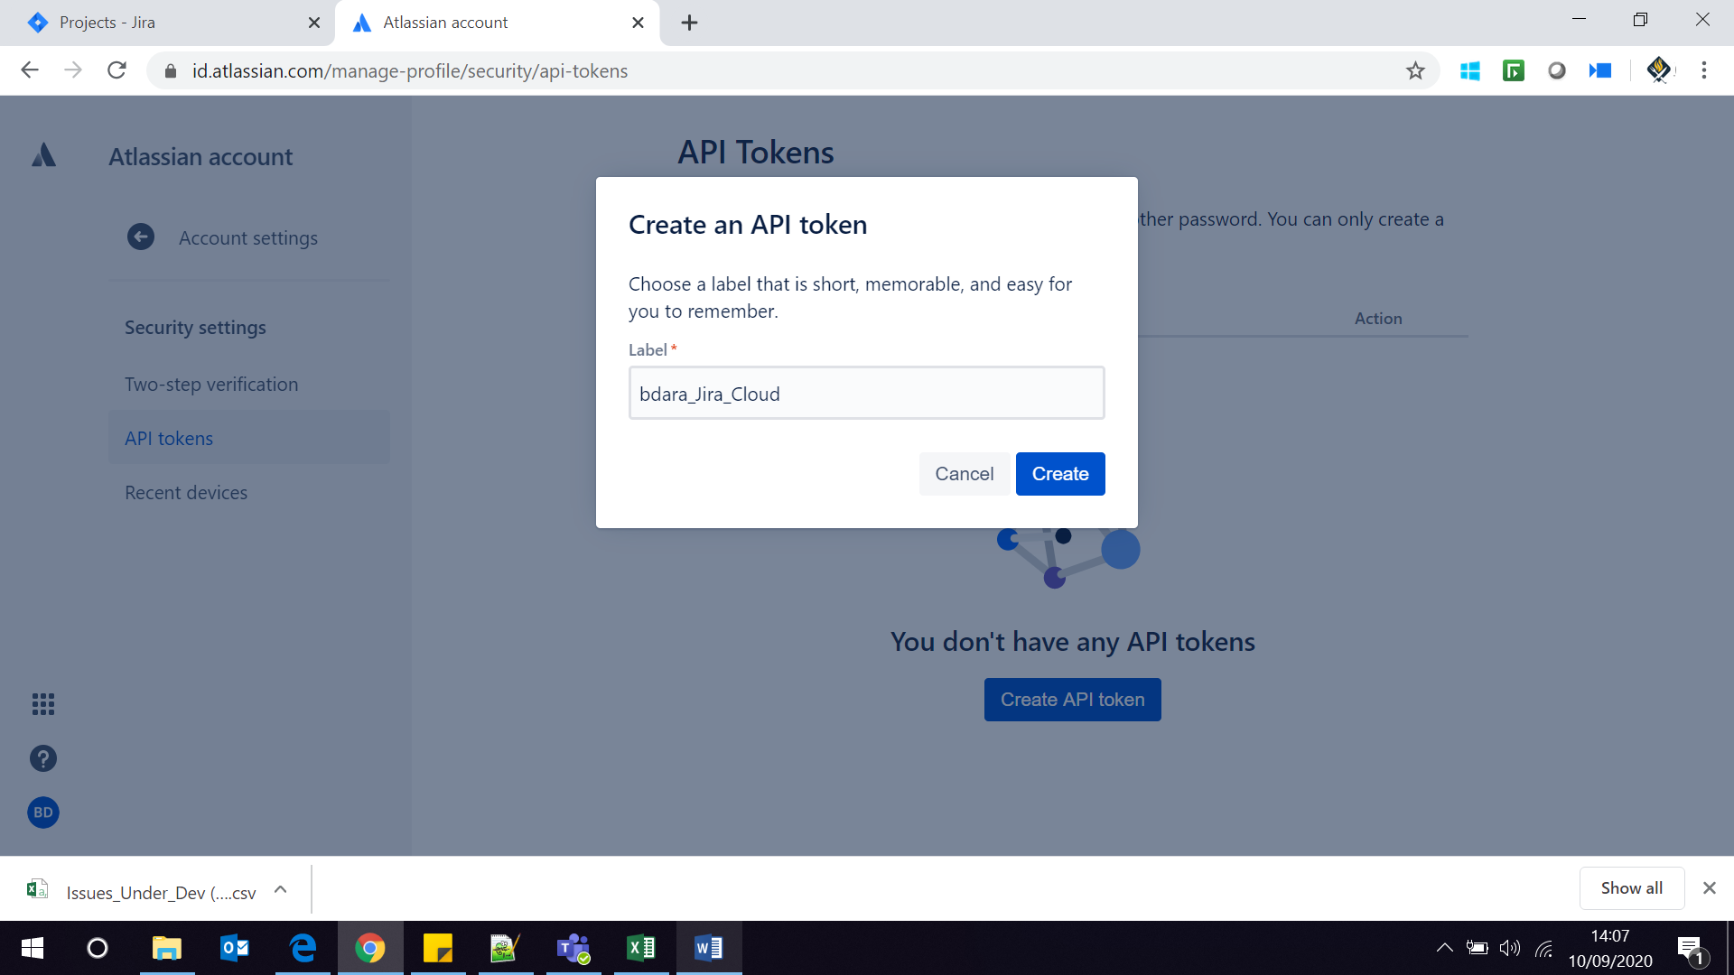

Bdara: 7jJA5DQfxHnkG7dLTt0G9B8F

Bachicute: TDrJCvHK0RMKKeghx4mJ62F1

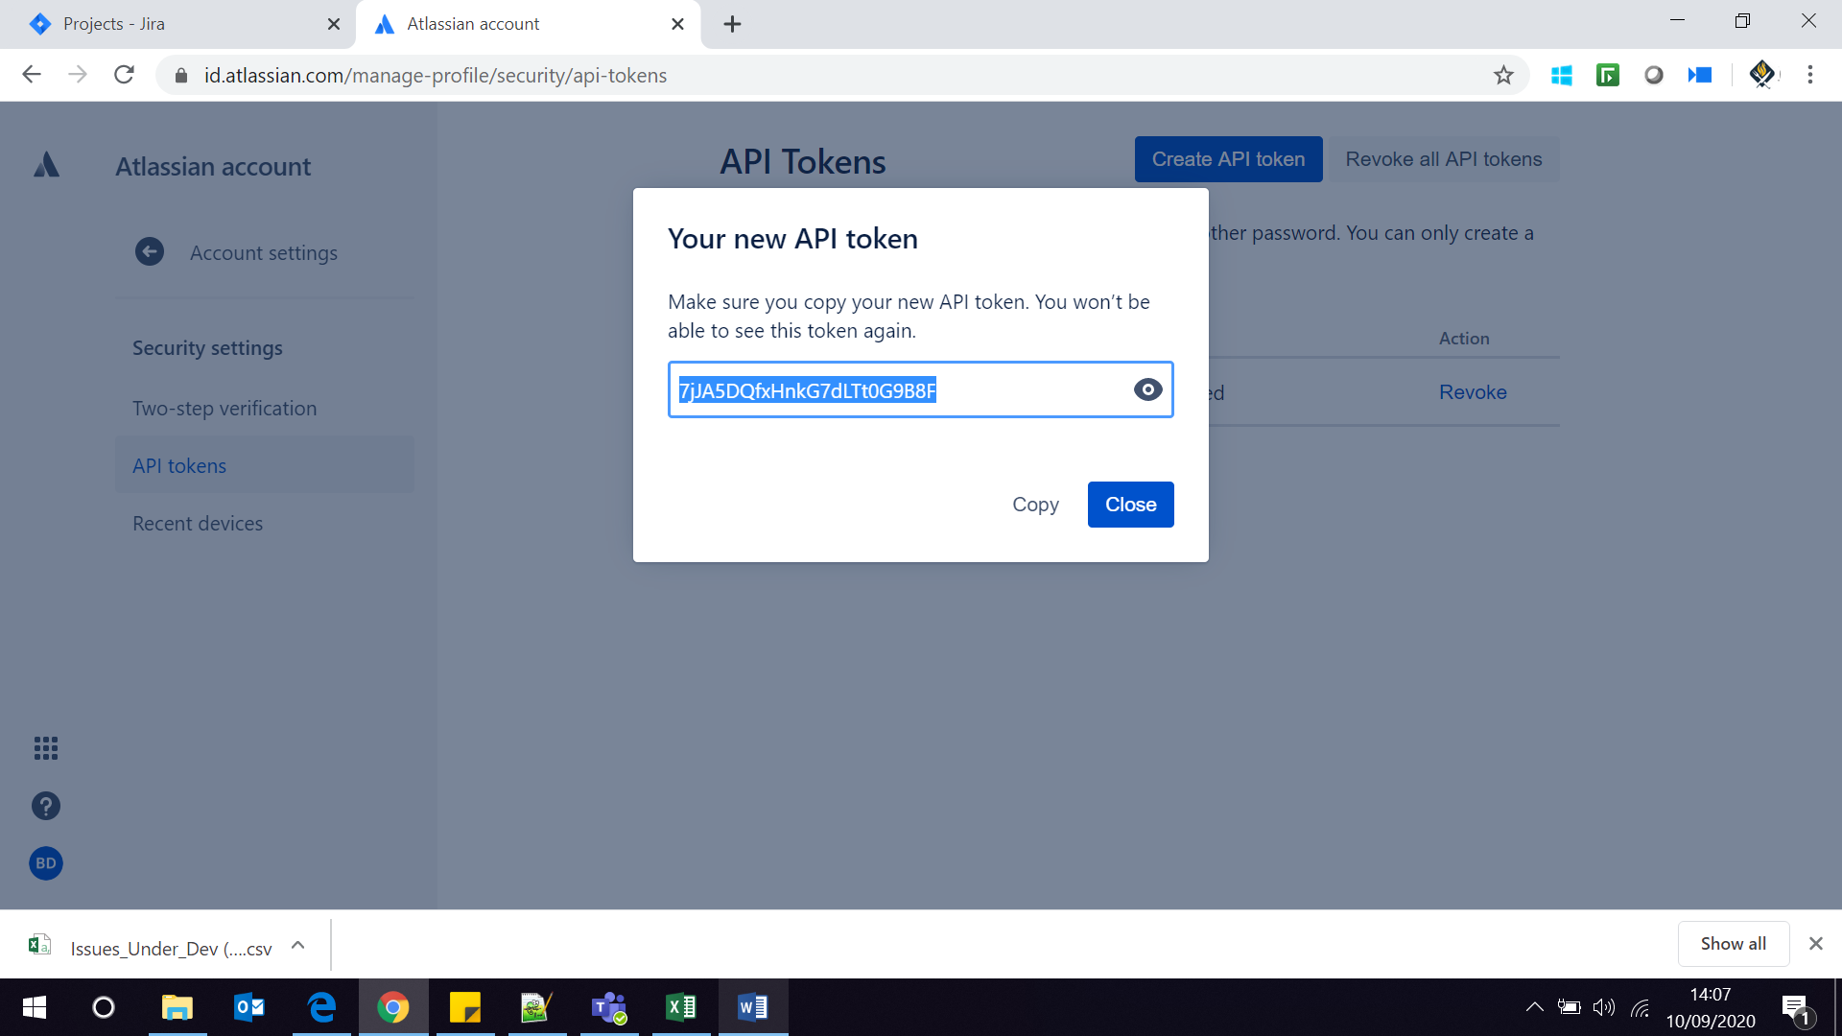

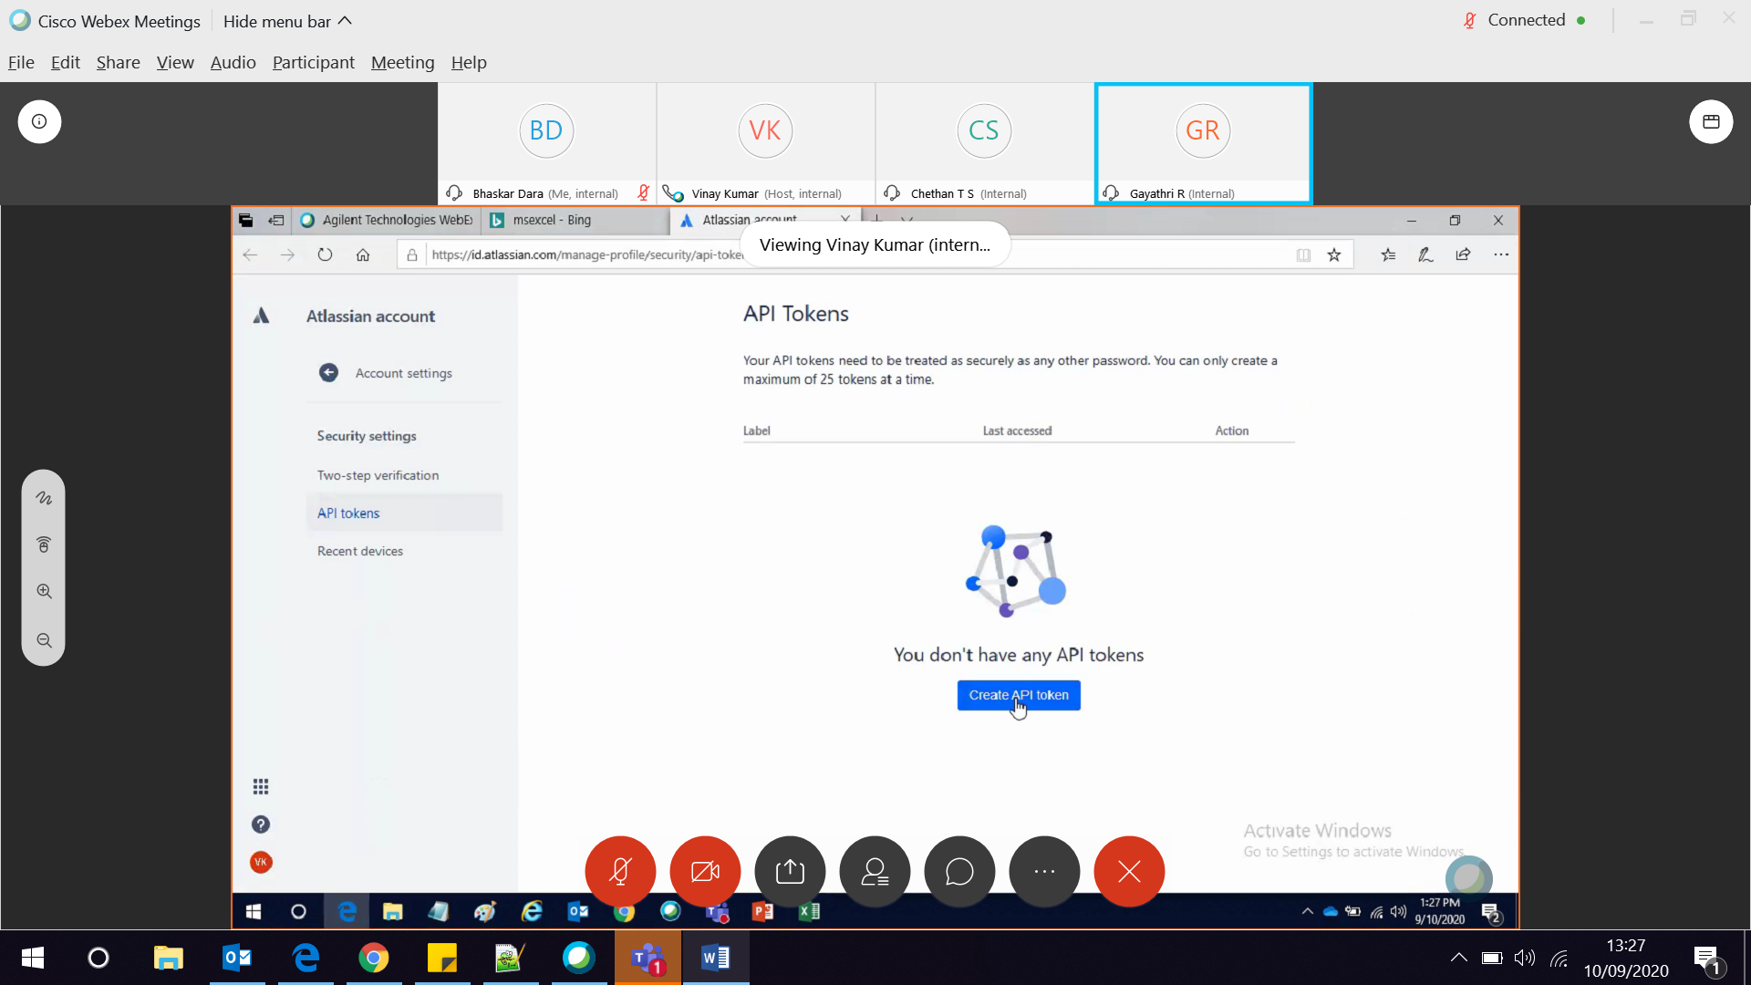

Create api token

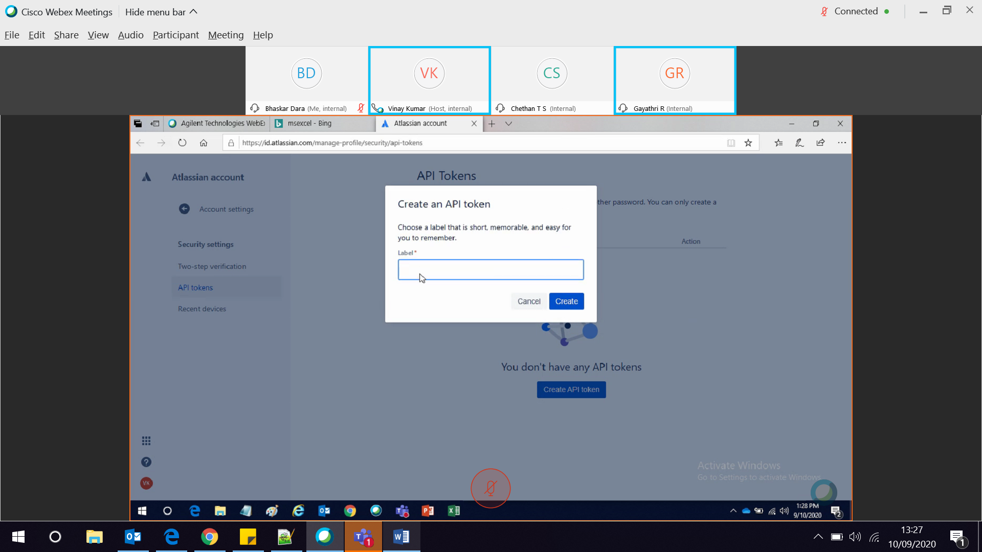

Give some label

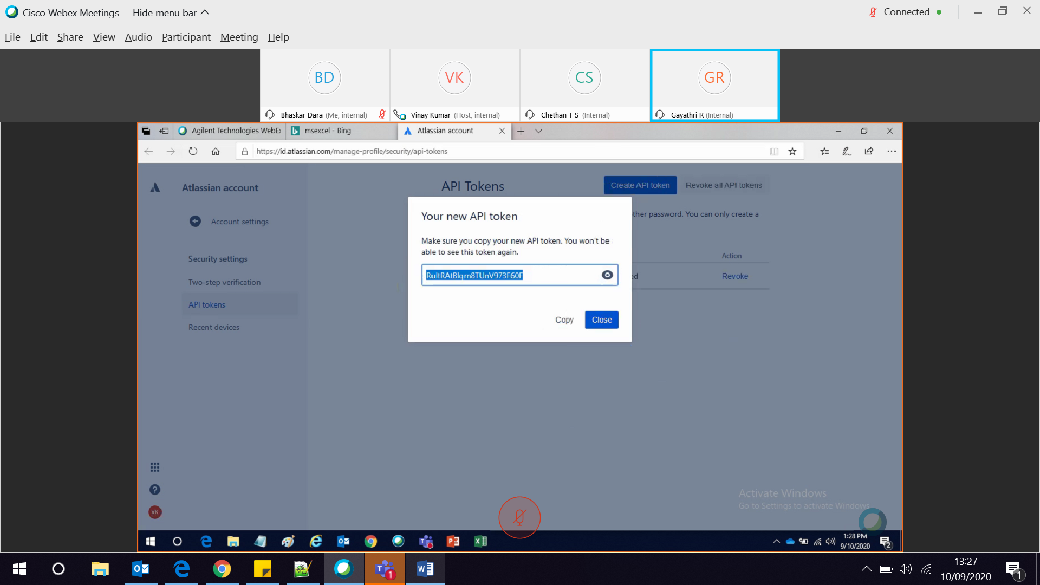

Copy the api token and keep it safe.

Go to excel and give under password.

